**`Hardware and software**

**Starter:**

* **Multi-functional devices**

It is a device that allows printing, copying, and scanning as well as providing additional functionality, such as scanning to email. Multifunctional devices are faster than conventional printers and have faster print speeds.

* **Personal computers**

An end user directly operates a personal computer rather than a computer expert or technician. Personal computers are intended for end users to operate directly. Can only be used by one person at a time.

* **Mobile devices**

A mobile computing device transports a computer during normal use to allow the transmission of data, voice, and video. Mobile computing is an interaction between humans and computers that involves mobile communications, mobile hardware, and mobile software.

* **Servers**

Several programs or devices, called clients, can communicate with each other using a server. This architecture is called the client–server model.

**Research the functions**

**CPU**

CPUs are primarily responsible for retrieving and executing instructions.

**RAM**

A computer's RAM handles all active tasks and apps. Without RAM, it would be impossible to run programs, play games, or stream online content.

**Secondary Storage**

To keep data and programs indefinite, secondary storage is necessary. If secondary storage were not used, all data and programs would be lost when the computer is turned off.

**Graphics Adapter**

Graphics card also called graphics adapter, is an interface between a computer and a monitor. The graphical information computed by a CPU transferred through this card to display images on a screen

**25/01/22**

**Task 1**

**Form factor**

We use form factors in hardware designs so we can describe the shape, size, and many other specs of components.

**Power efficiency**

In computers, power efficiency is the rate of computations which can be sent over by a computer for each watt transmitted.

**Cost**

Costs of computers are having a budget. The spending on storage and processors is also an area to focus on.

**Required performance**

Required performance relies on how accurate the computer is. One way you can check this is by doing work on the computer and seeing if it's too slow or if there are any bugs.

**Compatibility**

Compatibility is checked to see if you can run 2 software's at once. If you are unable to do so, then your computer is not compatible.

**Task 2**

# HP 15s-fq4553sa 15.6" Laptop - Intel® Core™ i5, 256 GB SSD, Silver

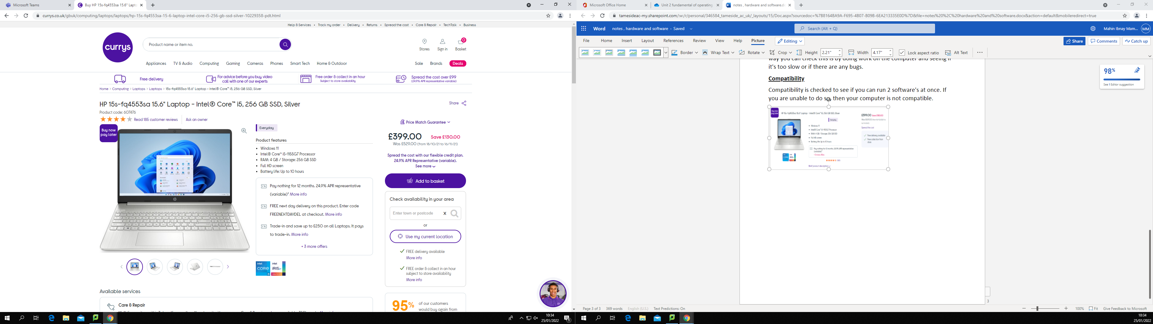

I would recommend this laptop. The reason for this is because it meets the scenario requirements. This laptop features:

* Windows 11
* Intel core i5-1155G7 processor
* 4 GB of RAM
* 256 GB storage
* Full screen HD
* Up to 10 hours battery life
* Only £399.00

**Task 3**

An output device is part of the computer's hardware, and its purpose is to transfer information for us humans to understand. For example, a printer will print out text or image onto a piece of paper. As humans we can read and understand from that paper. Whereas there is code in the computer which is harder for us to understand.

* Monitor
* Speakers
* Printer
* Headphones
* projectors

An input device is any physical component which can connect to the computer to help the user. Input devices are peripheral, and they are used to send data into a computer for processing.

* Keyboard
* Mouse
* Scanner
* Camera
* Microphone

**Task 4**

**Uses, advantages and disadvantages of input devices.**

**Mouse**

**Use:** Allows smoother and more navigable control of the user's interface.

**Advantage:**

* Light to carry and portable
* Can be used to easily draw
* Faster to work with

**Disadvantage:**

* Has many alternatives
* Needs to be connected to the pc